1. Install Jenkins

2. Create a task which will perform the following:

* Clone the project
* Launch tests from the project in Java directory with the help of mvn test goal.

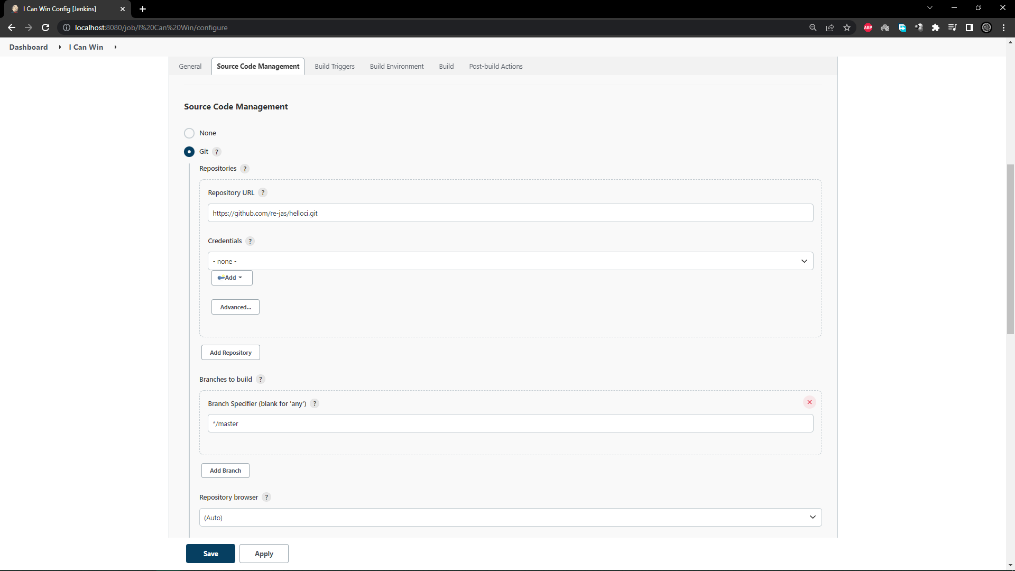

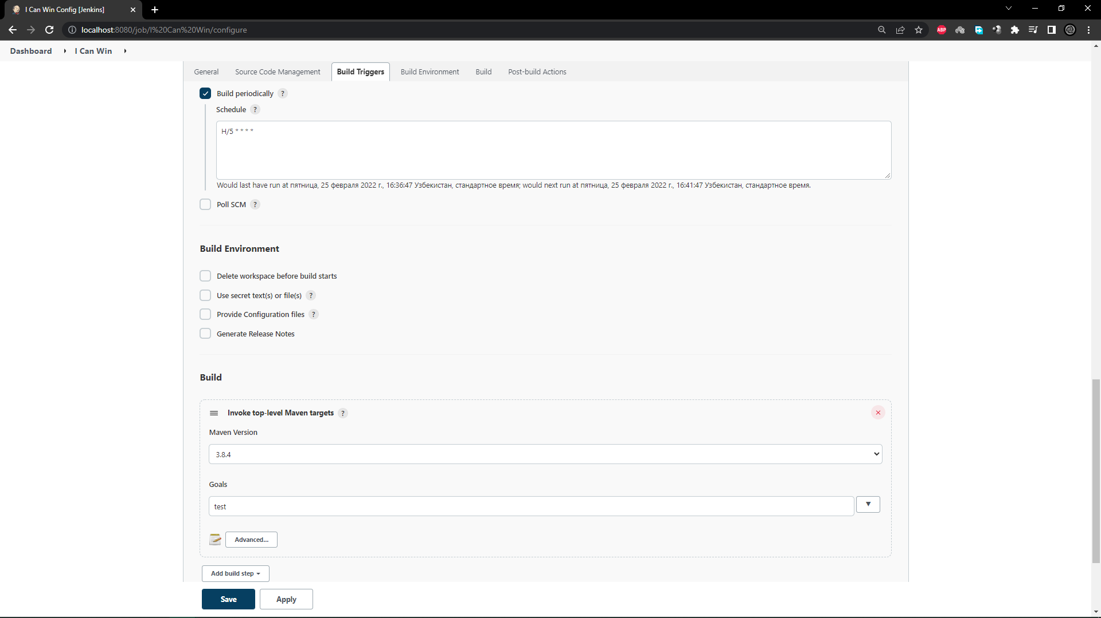

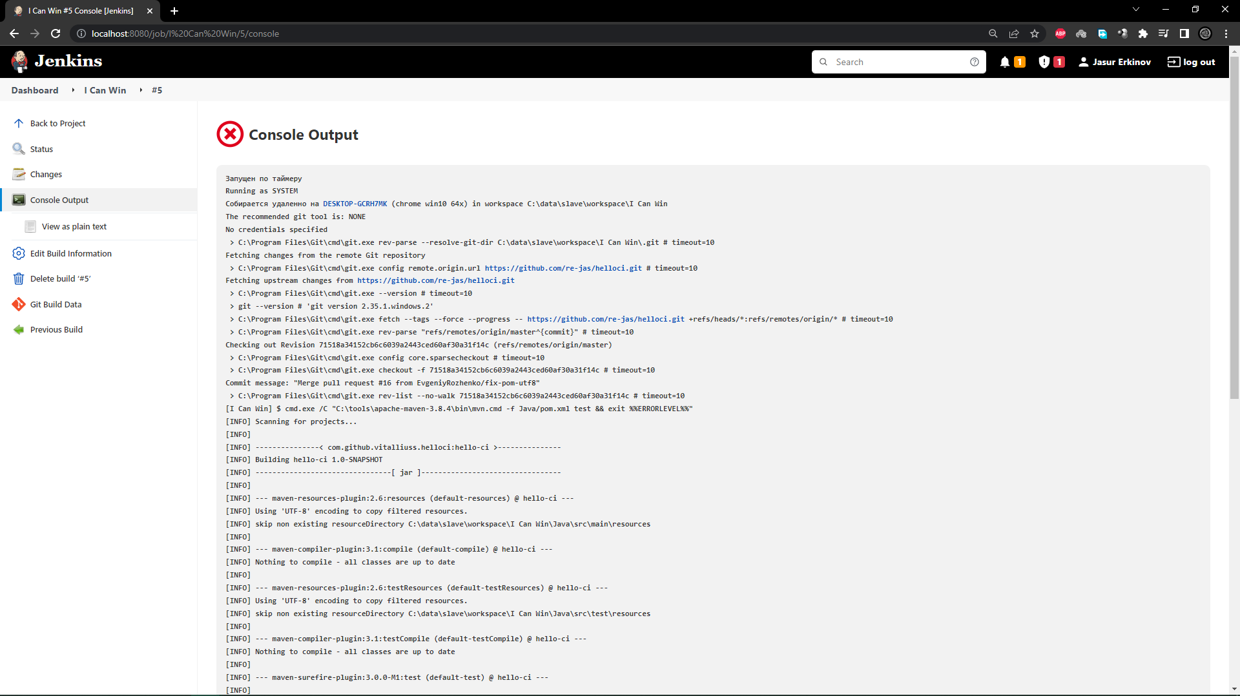

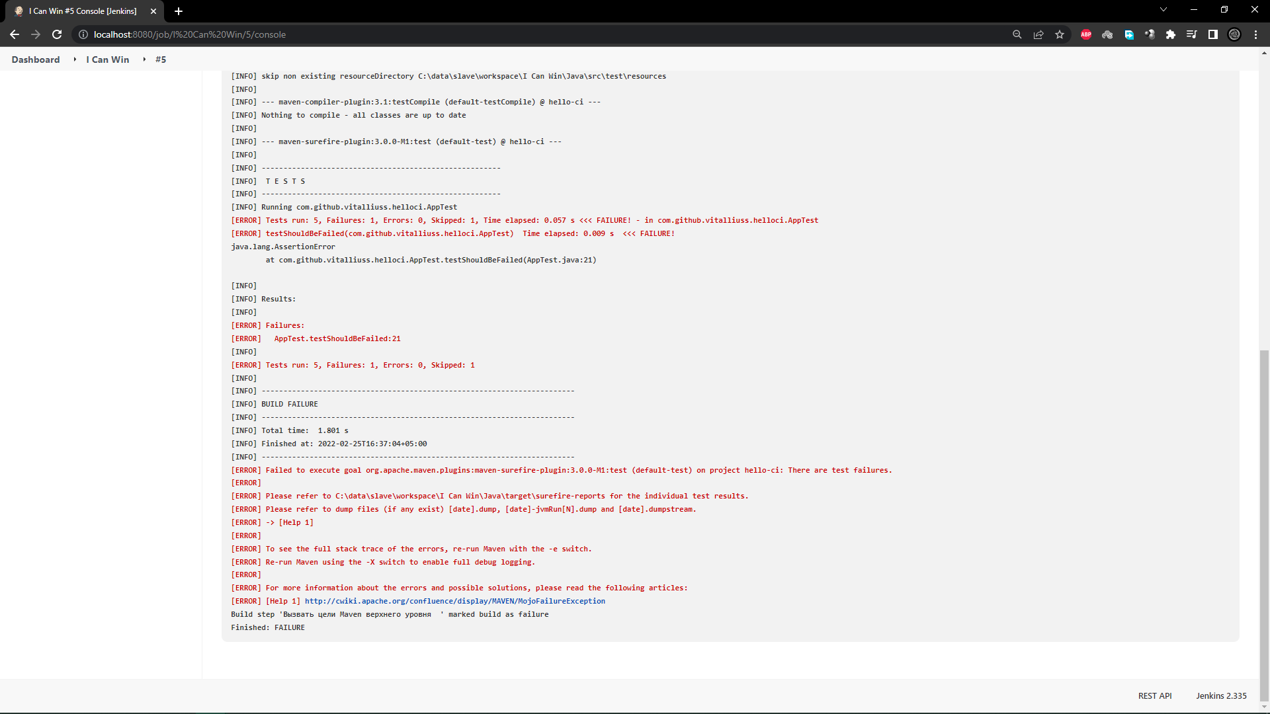

3. Set up build triggers so that the task is performed every 5 minutes.



